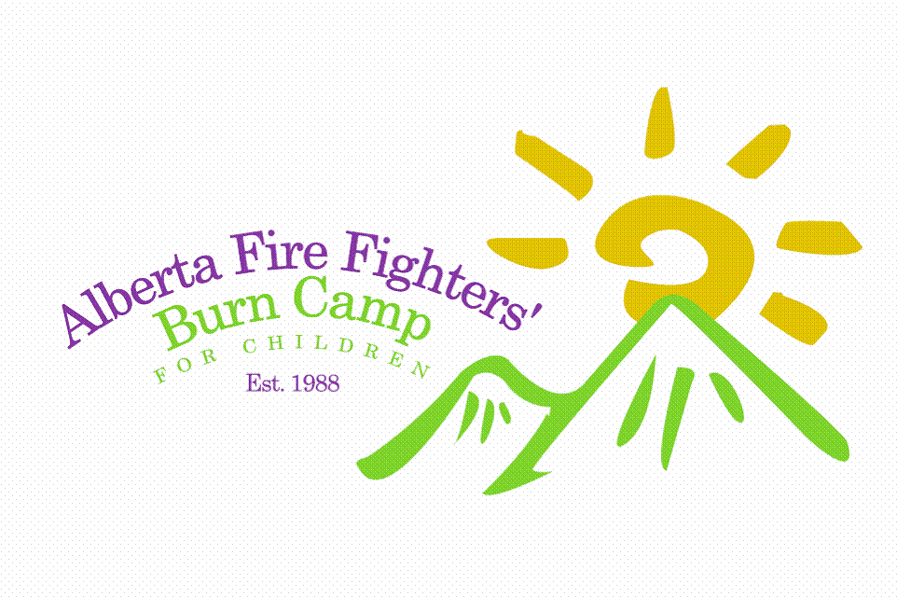

CHILD (under 18 yrs of age) or DEPENDANT ADULT

CERTIFICATION OF CONSENT AND AUTHORITY,
RELEASE OF LIABILITY, WAIVER OF CLAIMS, ASSUMPTION OF RISK AND
INDEMNITY AGREEMENT

I,___________________(Parent or Guardian) and ________________(Participant)
hereby acknowledge that we are aware that Alberta Fire Fighters’ Burn Camp partakes in risk-taking and potentially hazardous outdoor pursuit programs, including, but not limited to rafting, canoe trips, swimming, high and low rope adventure courses, teepee living, hikes, mountain and overnight camps, activities that involve physical activity and the possibility of injury resulting from such activity. In addition, I acknowledge that The Alberta Fire Fighters’ Burn Camp host facility contains physical hazards that may result in injury or death to persons or damage to property on or at the facility.

I acknowledge that it is the policy of The Alberta Fire Fighters’ Burn Camp and their host facility to take all reasonable precautions with respect to such activities and to provide a safe environment. As parent or guardian of the Participant, I freely consent to all such risks and fully assume all responsibility for the possibility of personal injury, death, disability, property damage or loss resulting thereof, howsoever caused, with the sole exception being gross negligence on the part of The Alberta Fire Fighters’ Burn Camp, their members, agents and directors.

I further waive and release any and all claims that the Participant or I have or may have in the future, on my own behalf and on behalf of the Participant, against The Alberta Fire Fighters’ Burn Camp and its supportive Foundations as a result of Participation at The Alberta Fire Fighters’ Burn Camp.

This consent shall be effective and binding on the Participant, heirs, next of kin, executors and administrators of myself and the Participant.

I have read and understood this consent and I am aware that by signing it I am waiving certain legal rights which I, the participant and our heirs, next of kin, executors or administrators may have.
Executed this_____ day of______ , 201_, at__________, Alberta.

__________________________________ _______________________________________
Parent or Guardian Signature Witness Signature

____________________________________ ______________________________________
Printed Name of Parent or Guardian Printed Name of Witness

